Stakeholders Meeting:

Education & Health
District Mirpurkhas

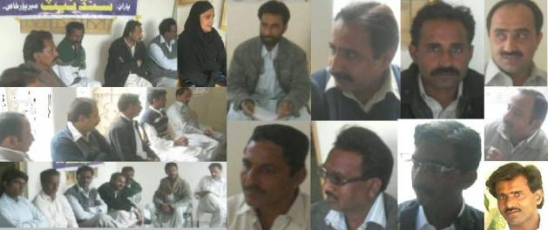

Organized by:
Socio-Institutions & Natural Resources Development Net (SINDNet), Mirpurkhas
Email: sindhnet04@yahoo.com
Website: http://sindnetmirpurkhas.tripod.com
Ph: No. 0331-2782473, 0333-2952480 & 0333-2953506.

Coordination:
Strengthening Participatory Organization (SPO) Hyderabad, Sindh
Preface;

Introduction of SINDNet - Mirpurkhas:
SINDNet - Mps. is an issue Based Network of 46 allied NGOs in district Mirpurkhas, working for its development, advocacy, awareness, and for uplift the average life here. It established in 2000 after successfully completion of DPM Graduate Training from SPO, Hyderabad. Due to the allied of registered NGOs, SINDNet, Mps. is an unregistered Issue Based Network of NGOs.

Rational for the Report:
This Stakeholders Meeting of the District Mirpurkhas was the in progression of the meetings sequence held from September 2009 up to onward where some decisions made and assessments done for the next plan. After monitoring and observations of a selected area of work, the department of Education and Health of district Mirpurkhas selected for making suggestions to improve these foremost departments.
The purpose of these meetings is to deliberate on the current situation in the field, to identify the problems and areas requiring attention, and to consolidate ideas on the way forward including on what areas SINDNet should focus its attention. It is on the basis of those recommendations out comes from the different stakeholder meetings.

A stakeholder meeting is a strategic way to derive usability objectives from main objectives, and to gain commitment to usability. It also collects information about the purpose of the system and its overall context of use.

Meeting Contributors:
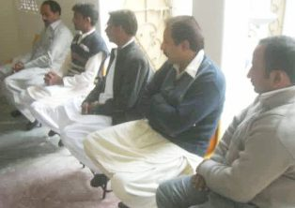
The Stakeholders Meeting of district Mirpurkhas was held on Thursday 23rd December 2010 time of 2:30pm at SINDNet Office, Mirpurkhas with collaboration of SPO (Straighten Participatory Organization) Hyderabad.
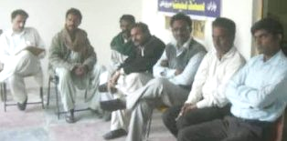
In this Stakeholders Meeting, the participation has seen as self-motivated and more proactive. Approximately 30 Stakeholders attended the meeting. SINDNet-Mirpurkhas has decided to arrange the meeting in equal approach like open forum. Such as, every attendee can bring his point of view freely without any vacillation and difference. All of the participants have retained the social and pleasant ambiance of the meeting and gently presented their views.
Reflection;

Presentation:
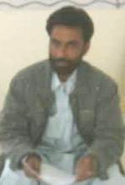
- Meeting Briefings:
Mr. Zahoor Laghari, Chairman / Coordination Secretary of SINDNet-Mirpurkhas has shortly briefed concerning the Stakeholders Meeting with all the participants and told some of activities done in the past. He also has given briefings concerning the support and structural coordination of SPO Hyderabad. He thanked all the participants and requested again to all the stakeholders for taking interests in maintaining the district management and for receiving ownership of departments.

- Welcome By:
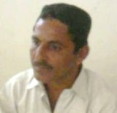
Dr. Hussain Marri Ex. Chairman of SINDNet & Executive member of IDARO welcomed the entire guest and thanked for spending their precious time in solving the problems of our district.

- Agendas:
  - Education: To activate the Education Committee.
  - Health: Analyses of observations and evaluate the resolutions of tribulations of Civil Hospital, Mirpurkhas.

- Recitation:
A verse from the Holy Quran was read by Shakoor Muhammad, Secratory Information & Publications of SINDNet, Mirpurkhas.

- Introducers:
- Zahoor Laghari:
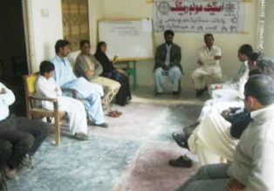
The Chairman / Coordinator of SINDNet spoken as “Our Management system of education is the core branch of producing the genius citizens. However, here it has many faults in its path where different policies and different commands are running. Most of Officers are just in commanding positions and working in an imperative mood of working. Education should be natural and within its own soil and culture. It can run with social manners and behaviors in a friendship atmosphere. I would like to suggest them to attend these kinds of social events such as Civil Societies Meetings, Seminars, Workshops and many others activities. It can improve the structure of our behaviors and related environment.

Discussion under the Agenda of Education:
Agenda wise Discussion was discussed; under first agenda discussion i.e the issue of Education was in debate:
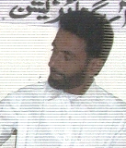
- Zahoor Laghari: Chairman SINDNet first briefed about two Vigilance Committees formed in SINDNet one Education Vigilance Committee and other Health Vigilance Committee and told their moods of working. Due to the low interest and slow results, he emphasized to activate the Committees. On the request from RDI Chairman inquired all the members to discuss whether SINDNet have to work with RDI and activate the same committees with coordination of RDI committees?

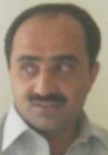
- Muhammad Bux Kapri: Journalist and Finance Secretary of RDI said that their organization (RDI) planned to survey the Schools at rural areas for assisting better management to District Education Department. Due to lack of resources their survey is still uncompleted and seeking organizations for support. We have done some of survey and got actual Data, according our planned survey, we have to work in a specific talukas & UCs of the district Mirpurkhas. Recently, we have surveyed and collected data of ten schools among seventy Schools. Due to remote area schools and inadequate transport facilities it is still remaining. More he added, as our Network SINDNet is also working on the issue of Education, it is our request to include our survey committee with the committee of SINDNet.

- Dr. Hussain Marri: Ex-Chairman SINDNet said; for one and half year SINDNet is struggling for better coordination between all the working fields of education. It is very appreciative for the SINDNet that it is paying its active role in the society. Being a long term and very sensitive issue, it can’t complete without the support of local area stakeholders. In my point of view, it is necessary to activate the Education Vigilance Committee with motivated and affecting efforts and supports. It is very enthusiastic for RDI which requested SINDNet to work together.

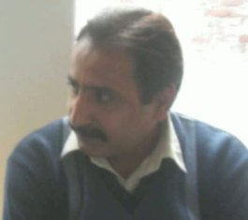
- Ghous Jatoi: Politician and central leader of “AWAMI JAMHORI PARTY” said; Our Child Education is not able to create generosity it is going very bad and the level & standard of education is going down day by day. Even most of primary student don’t know writing and reading. Through reliable resources I can say some teachers are absconder as went on “VISA” and education management supporting and hiding them, it is necessary to include this kind of survey in present observations of committees. It is appreciated to work for promotion of Education. Here in this stakeholders meeting what ever responsibilities giving to the members, they should be fulfilled with emotional attachment and with extra ordinary efforts. It’s our national cause; we all have to be realistic and faithful with the issue. At another point he emphasized SINDNet for invitation process.
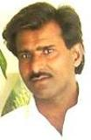
- Muhammad Rafique Khatri: General Secretary IDARO and Secretary SINDNet said Education is the core department which creates the sophisticated, intelligent and educated peoples for all the other departments in the society. It needs to move forward with its policy planned path and management. It is the long term planned process which at least needs twenty years for completion of one generation cycle. But unfortunately our Education Policy is still under discussion and not conformed to all the cultural and provincial nature in the country. Periodically it changed several and cant completes the even its first generation cycle. It is a separate discussion to discuss on Education Policy, but for the time being, we have to measure the steps taken with present Education Policy. That what our district education is according to the policy and have all the resources needed for the Educational Cycle? To maintain its required level and standard, Civil Society have to support district education department.

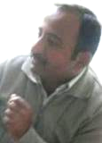

- Shehzado Malik: Chairman ARTS Foundation said it is necessary to continuous the survey Program of RDI, I myself has worked with the education committee of RDI and found some lacking of resources. While SINDNet is also working the same. Now RDI requesting to work with SINDNet, it will be very appreciative and collective. It is my suggestion to form committees again and on periodic basis reports have to collect from the committee head. Concerning these committees a meeting of all the committee members is necessary. We have to made data concerning every field of Education, including teaching staff, students, infrastructure and mood of education, needs of schools and provisions present in the schools. In this way if we are not able to provide them materials than we must have to awoke them by making reasonable suggestions and comments.

- Madam Nasreen Bano: President RSDO said during the survey and visiting the schools, we should have to reach school without any caution or intimation such as we can collect the real picture of provision and data of the school.
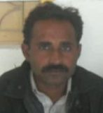
- Dr. Anand: Politician and leader of a Nationalist Political Party said most of school has extra school staff and very low enrollment. It came in my notice; a High School has the staff of 18 teachers where only 24 students are enrolled. In the rural area schools, most of schools are One-Teacher-Schools and some of them are over crowded.

- Shakoor Muhammad: Secretary for information and Publication of SINDNet inquired for the mood of support and resources which SINDNet will provide to RDI. What ever and how the funding problem will solve for the said survey. But soon after getting details, he realized.

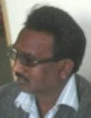
- Khalid Parvaiz: President of an allied NGO of SINDNet said education issue is the time needed issue and it is appreciative for SINDNet who has taken the initiative. The mood of working is also good and all of the members are looking very ambitious. With this team sprit we can fight against the illiteracy.

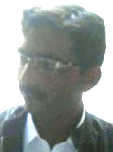
- Vissan Lal: Activist and social worker said Education is our problem and we are responsible to solve. It is common complain that teachers are not paying their right job to the nation. It is seen in a school where 300 students are enrolled and only one teacher posted. It is mismanaged. Clearer picture will in vision after survey of schools.

Discussion under the Agenda of Health:
Agenda wise Discussion was discussed; under second agenda discussion i.e the issue of Health was in debate:
- Dr. Hussain Marri: Ex-Chairman SINDNet said; we are the habitant of this district and belongs with civil society network have rights to inquire whether our department are consequence result making or not? After Education department, health department is the second largest department having manpower force. And both are responsible to maintain the psychological and physical health of all the habitants in the society. SINDNet is observing the Civil Hospital of Mirpurkhas since last year. And the present Health Committee presented reports. Last stakeholders meeting was held with reference of the health reports and it is very appreciative that Civil Surgeon and other officials from health department not only attended the meeting but also showed their keen interests. The comments and suggestions made in the meeting were sent to them. But SINDNet is consecutively observing the managements, health provisions, and facilities provided at Civil Hospital. The Health Committee needs to boost its activities more frequently.

- Shakoor Muhammad: Secretary for information and Publication of SINDNet who is also the committee member of the Health Committee insisted to equipped the committee with required needs and members such as the survey and observation can be effectively made and data of survey becomes actual. Also he suggested to reconstruct the health committee with ambitious and efforts taking interested members who can spent their precious time for this noble cause of serving mankind. He notify the problems of availability of doctors at OPD and told about complains of medicine.

- Vissan Lal: Activist and social worker said there are mismanagements of doctor’s duties during day and night timings. Often night time delivery cases faces problems of available doctors and other staff. There no any schedule or chart placed at any wall of the department in the Civil Hospital of Mirpurkhas. It is my suggestion to notify the names of doctors and other staff with their phone numbers for the patients.

Sum-up the Discussion:
- Zahoor Laghari: Chairman SINDNet sum-up the discussion with informing the decisions made here in this Stakeholders Meeting and also with announcements of names of selected members for the vigilance committees. For making format and moods of survey the selected committees will held a meeting on dated 3rd January 2011 at SINDNet Office Mirpurkhas.

- Vigilance Committees Formed:
Two Committees formed for the survey and working in selective field of work;
- Educational Vigilance Committee:
Consisting Members:

  - Mr. M. Bux Kapri.
  - Mr. Shehzado Malik.
  - Mr. Ali Hassan Non.
  - Mr. Hafeez Khaskheli.
  - Mr. Imtiaz Lodho.
  - Mr. Shair Ali Lodho.

- Health Vigilance Committee:
Consisting Members:

  - Dr. Hussain Marri.
  - Mr. Shakoor Kuhammad.
  - Madam. Muneza Siddiqi.
  - Madam Nasreen Bano.
  - Mrs. Fariya.
  - Mr. Vishan lal.

- Decisions:
- It was decided that SINDNet will support and work with the team of RDI.
- New Vigilance Committees formed and will move forward after a reconsideration meeting which will hold on 3rd January 2011.
- Survey will restructure and collection of data, further suggestions and comments will make on the bases of collected data.
- Selected committees will held a meeting on dated 3rd January 2011 at SINDNet Office Mirpurkhas.

Hi-Tea:
All the participants and guests were served by refreshment and lunch at the end of the Lecture.

_________________
(Zahoor Laghari)
Chairman,
SINDNet – Mps.

Annexure – I Photographs:
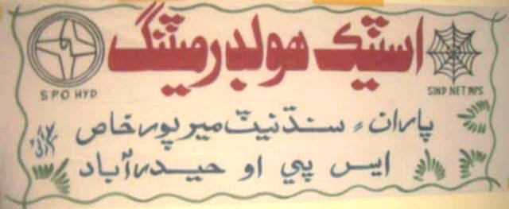
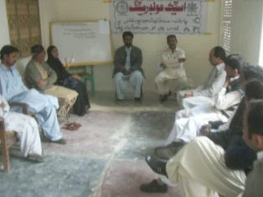
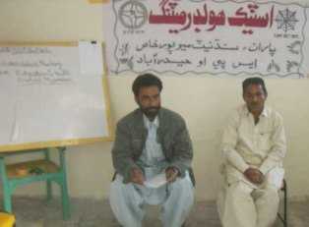
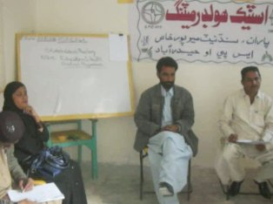
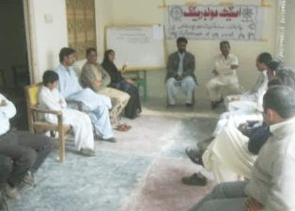

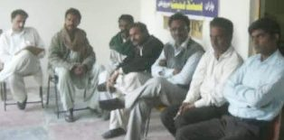

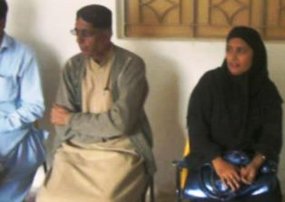
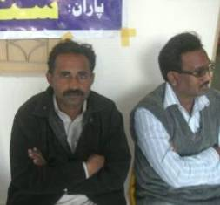
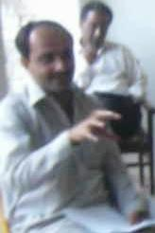
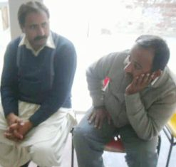

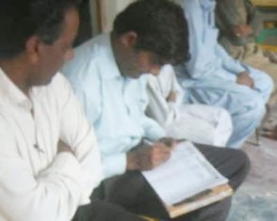

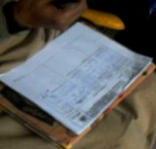
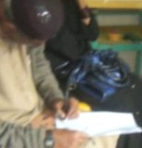

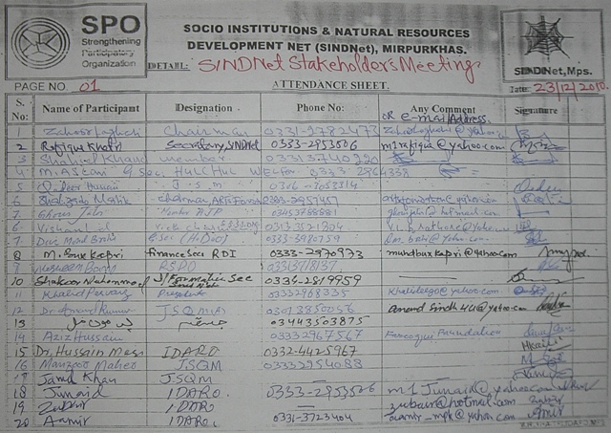
Annexure – II Participants Lists:

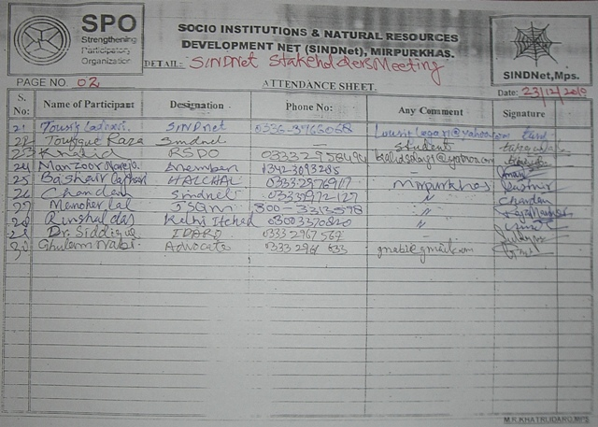

Annexure – III Media News:

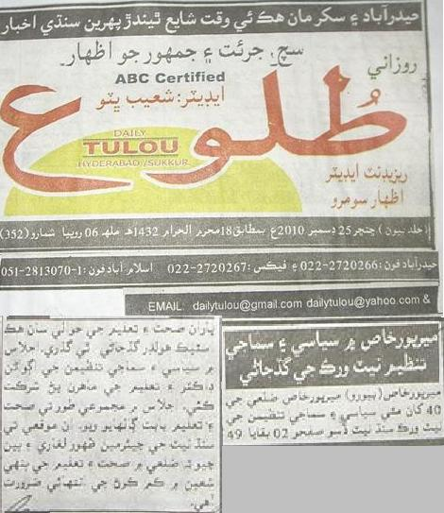

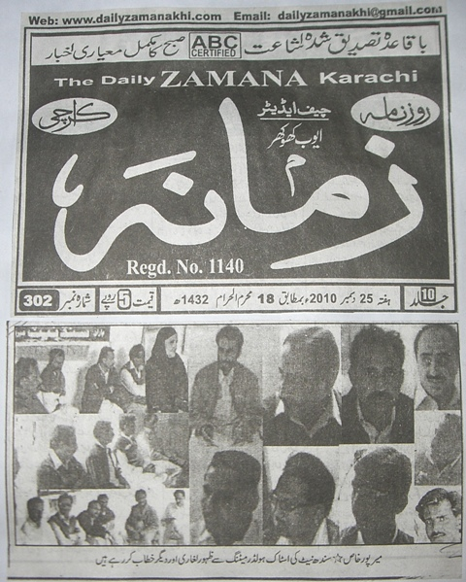
Annexure – III Media News:

