Lecture Program:

Flood & its Effects
After the Disaster in Sindh

Lecture by:
Dr. Arbab Khawar.
Senior Vice Chairman, Jeay Sindh Mahaz

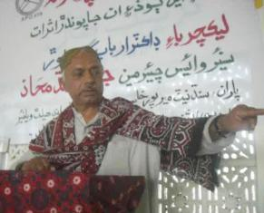

Organized by:
Socio-Institutions & Natural Resources Development Net (SINDNet), Mirpurkhas
Email: sindhnet04@yahoo.com
Website: http://sindnetmirpurkhas.tripod.com
Ph: No. 0331-2782473, 0333-2952480 & 0333-2953506.

Coordination:
Mehran Education & Health Welfare Organization,
Nabisar Road, Near Judho Town, Mirpurkhas

Sponsor:
Strengthening Participatory Organization (SPO) Hyderabad, Sindh
Flood & its Effects, After the Disaster in Sindh:
Abstract:
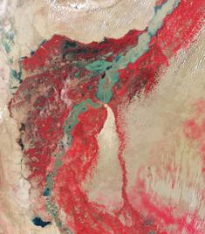
Recent flood in Sindh caused by heavy monsoon rains began across several regions of Sindh. This flood is one of the worst seen in the history of subcontinent. According to the Associated Press, the floods have affected about one-third of this Sindh of more than 110 million Peoples. And tens of thousands of villages have been flooded, more than 2,000 people have been killed, and millions have been left homeless and destroying millions of acres of cultivated lands, demolishing millions of homes, rendering half a million people unemployed. Disease, misery and death are on the order of the day. Apart from the immediate devastation produced by the flooding, life threatening infections have spread like wildfire in crude camps. The lives of hundreds of thousands of children are at risk; they can die at any time if there is no proper intervention. Hunger has also put life at further risk.

The Sindh government has failed to provide sufficient relief to these poor victims. The rot of the state machinery has been exposed as has the uncaring indifference of the rulers. Different representatives of the elite are doing photo sessions and bickering over the disaster management. But the real faces of these puppets of imperialism will be exposed further as time goes by and the situation worsens. The floods have destroyed the entire government already weak infrastructure. Major towns and cities have lost their means of communication. This has added further to the misery of the people.

Imperialism and Capitalism is showing its ugly face in Sindh; the complete failure of this system has required millions of people to live in hell-like conditions. Floods have further exposed the inability of this profit driven system to deal with such disasters. Despite warnings of flooding a month ago, no preventive measures were taken to save the people. Despite knowing the weakness of the safety dykes no repair work was initiated. The disaster management authority has been dysfunctional for years and exists only on paper. It was not made functional as a precautionary measure.

When the water entered in Sindh from the Sukkur barrage, the safety dyke known as “TORRI BUND” was broken, instead of the “ALI WAHAN BUND” which was the one to be broken to give safe passage for the water away from the populated areas. But the reason why “ALI WAHAN BUND” was not broken was to save thousands of acres of land belonging to people at the top in the ministries and the army officers. The decision to cut the dyke of “TORRI BUND” provoked endless destruction which still continues. The water flow directions became unnatural and out of control due to self welter wishes of ministerial Authorities.
Preface;

Introduction of SINDNet - Mirpurkhas:
SINDNet - Mps. is an issue Based Network of 46 allied NGOs in district Mirpurkhas, working for its development, advocacy, awareness, and for uplift the average life here. It established in 2000 after successfully completion of DPM Graduate Training from SPO, Hyderabad. Due to the allied of registered NGOs, SINDNet, Mps. is an unregistered Issue Based Network of NGOs.

Rational for the Report:
SINDNet - Mirpurkhas from the very first day of the disaster launched a Flood Relief Campaigns. This Relief Campaign has been providing basic necessities along with the Eid-gifts and new Clothing and Dresses. The Campaign was last up to 30th Sep: 2010 but moral assistances, approaches and struggle for the rehabilitation of flood effecters are still in connectivity with them. In this connection, SINDNet is requesting all the political personalities, Social workers, media Journalists, Authors, writers, poets and management planners to work for the flood effecters until they all be rehabilitated their cultural, social and normal daily life.
In view of the current situation of the flood affected areas in Sindh; the flood came from the north-western boundary with Balochistan and it hit the districts of Shahdad Kot/Qambar and later on Dadu district. Mula and Boolan Rivers brought the major flows, which breached FP Bind at RD 179, 180, 184 and 230. It set off a series of breaches and cuts and 34 breaches and cutes were recorded in MNV Drain. These breaches flooded several small and large villages and it also threatened Qambar and Shahdad Kot towns. A detailed Technical Assessment is required to establish the role of infrastructure and management system responsible for this disaster. A rapid assessment based on site visits, meetings with local communities, irrigation experts and civil society groups is necessary to be consulting for rehabilitation.

To understand the causes of this crisis and its solution SINDNet – Mirpurkhas invited a Nationalist Politician Dr. Arbab Khawar, senior vice President of “Jeay Sindh Mahaz” to deliver a lecture.

Recital of the Lecture:
The Lecture Program was held on Tuesday dated 7th December 2010 at the Training Centre of Mehran Education & Health Welfare Organization, Town of Nabisar Road, Near Judho Town district Mirpurkhas with its coordination and local support. The program was sponsored by SPO Hyderabad. More than 100 participants including press journalist, Social and political personalities, local stakeholders, businessman and students has attended the lecture program.
Reflection;

Presentation:
SINDNet – Mirpurkhas arranged the Lecture program by management of its member organization named Mehran Education & Health Welfare Organization and thankful for its coordination and arrangements. A list of Participants is given at Annexure – II
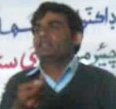
- Compeering:
Mr. Muhammad Aslam Kumbhar, from a member organization of SINDNet paid conditional and model compeering with stage invitations of guests and speakers.

- Recitation:

At the beginning of the lecture a Participant Mr. Moulana Manzoor Ahmed read a verse from the Holy Quran.

- Welcome By:
Mr. Mukhtar Amed Ghishkori, Prsidant of Mehran Education & Health Welfare Association and Program Organizer has welcomed and thanked all the participants and guests.

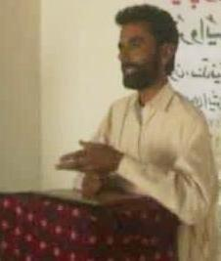
- Condolence:
After the recitation, Mr. Moulana Manzoor Ahmed was told by SINDNet to pray for Shaheed Sultan Mehmood Chandio, media Journalist of our district Mirpurkhas and President of Mirpurkhas Press Club who was killed one day before this lecture program.

- Introducers:
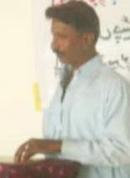
Mr. Zahoor Laghari: Chairman SINDNet has given a brief introduction of SINDNet – Mirpurkhas and SPO – Hyderabad to the audience. He stated working mood of SINDNet and told aims and objectives of the program. Also he described progress and work done by SINDNet, Mirpurkhas.
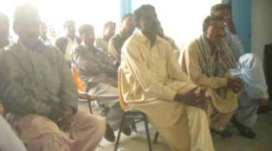
- Refresher:
Mr. Khalid Mujahid Chandio, sung a beautiful poem. All the participants encouraged him on singing beautiful stanzas by clippings, praising and flattering.
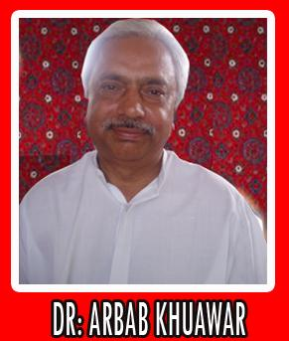
Lectures discuss: Flood & its Effects after the Disaster in Sindh:
Dr. Arbab Khawar:
Politician and Nationalist Leader Mr. Arbab Khawar, Senior Vice Chairman of “JEAY SINDH MAHAZ” has vast study of Sindh and having facts and figures to describe the real crises and agony produced by the present rulers and government. His party is struggling for the self determination and souernity of Sindh.
Before starting the lecture, he informed all the participants for inquiring the understandings of difficult facts and figures because the lecture has some typical data reference with the topic. Also he welcomed and thanked all the participants for having keen interest in his lecture.

Lecture:
Concerning the topic he stated;
Barrage is also a kind of dame. Most of the floods generates by the heavy rain and thunderstorms. In Sindh, this year monsoon rain generated immense disaster in Sindh. It is necessary to know that this year why monsoon rain changed into very destructive nature.
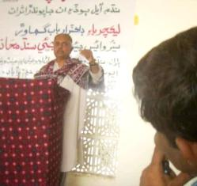
Here in Sindh, the causes of rains are those hot windflaws flowing in Sindh are when disturbed by the cold windflaws arrived from Siberian regions. Where these hot and cold windflaws collapsed each other, monsoon rain produced. In usual tempo of monsoon, the region where it collapsed naturally is the northern region of Sindh. But unfortunately, this year it collapsed upper side of Punjab Province and caused heavy water of monsoon rain in the Indus River.
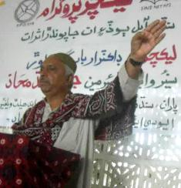
Another reason of the flood is climatic changes occurred in the Sun. Our Earth is revolving around the sun and nine to ten other planets are also revolving around the sun. Most of planets having its own planets revolving around them like moon. All of this system is known as our “Solar System” in the Universe. As all the planets are under the influence of the Sun and radiations from the sun reacts on its planets. The solid Earth releases a portion of its heat in the form of infrared radiation, which is trapped by atmospheric greenhouse gases, further raising the surface temperature to a more comfortable 15°C. In this way, the Sun's radiation and the Earth's blanket of greenhouse gases sustain the mean global temperature at a level supportive of life. Sunlight also powers photosynthesis, and provides energy for the atmospheric and oceanic circulations that profoundly affect all living things. At the time of monsoon rain, a kind of storm was noticed in the Sun. According to media reports, Asian regions like China, Afghanistan, and India were also affected by the solar radiations and caused heavy rains, floods and thunderstorms taken place on the region.
The Siachen Glacier is the region where Indian and Pakistani army made immense bomb blast which cause the glaciers to melt more than usual. It also increased the water level of the Indus River.
At the upper side of Sindh, river water flows under the ground and divided in different rivers, canals and branches. There, the water level was increasing not scattering. While; in Sindh the river water flows up at the ground in scattered situation. In the Indus River when all of total flood water gathered at the border of Sindh, it was needed to give extra passages. But it cant managed and destructions was made at large scale than the other provinces of Sindh.
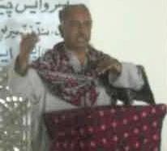
According news reports, in June flood warnings neither alerted ruler of Sindh, no any measures taken in before nor managed any kind of rescue system. Despite warnings of flooding a month ago, no preventive measures were taken to save the people. Despite knowing the weakness of the safety dykes no repair work was initiated. The disaster management authority has been dysfunctional for years and exists only on paper. It was not made functional as a precautionary measure. Meanwhile, the flood reached with huge amount of water level in the Indus River. In panic, only one option and decision for extra passages was cutting dykes remained.
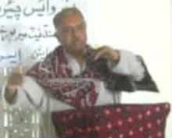
When the water entered in Sindh from the Sukkur barrage, the safety dyke known as “TORRI BUND” was broken, instead of the “ALI WAHAN BUND” which was the one to be broken to give safe passage for the water away from the populated areas. But the reason why “ALI WAHAN BUND” was not broken? Several years ago, the English empires have given a written testimony for safety of flood ever occurred in future. That the “ALI WAHAN BUND” is the safe passage because it has vast area of “NARA” and have no population. At the time of flood, it was the safest option.
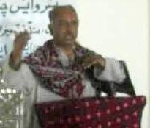
Now what was happened, these putative so called authority saved the National High Way and Railway Lines on which most of import export of Punjab depends. They saved manmade property instead of innocent Sindhi peoples of Sindh. Yes they saved the National High Way and Railway Lines because Daily 600 trucks loaded with US army’s daily ration and other stuff moving from Karachi Port to Afghanistan. And USA paying them transportation charges in which their own interest of income was greater than human beings living in Sindh. Also these daily 600 trucks are creating problems of traffic risk of life for us at roads. No any precautionary measures taken before allowing USA to move daily 600 trucks movements on our land.
Apart of all of above reasons, The Shehbaz Army Airbase of Jacobabad is the Airbase for the US Army from where USA managing Drown Attacks and their other interests. For safety of few American Solders they cut dykes other than “ALI WAHAN BUND” where millions of innocent Sindhi Peoples living. While, it was observed the American Army using only Air ways for their communications instead of road communications.

At the region of “ALI WAHAN BUND” the vast area is very likely for cultivation. Hundreds of miles area is safety sides for Indus River where natural jungle is located and needs more congested jungle for better and safe passage of Indus Water. Here many “Royal Land Lords” as Jatoi, Chandias and others occupied thousands of acres land earning millions of rupees. Every Land Lord has his own land safety dykes and thousands of watchmen with weapon. The “Royal Land Lords” has repaired their forcible dykes. Their ruling is for their own self development not for the peoples. As pressure of Army increased for cutting dykes, some of “Royal Land Lords” reluctantly allowed flood water in their lands.
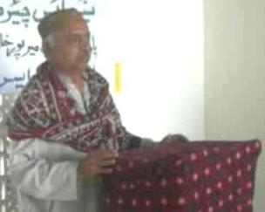
Some peoples from Kandhkot Town arrived and told me that for safety of a “Gas and Oil Field” managing by a foreign company in Sindh was told by mistrial sources, if they will pay them 20 million rupees for construction of safety dykes to save their “Gas and Oil Field” they will do more otherwise it will leave its own. Coercively the foreign company paid them and all the MNAs and MPAs has shared.
Another safety dyke which I myself visited and observed is a dyke of dust and stone with measurements of two thousands feet long, twelve feet in height and five feet in width constructed by Army’s controlled agency FWO (Frontier Works Organization) with cost of two hundreds and twenty millions rupees. Any normal person can easily estimate that it can easily construct with half million rupees only……..!!!! At the time of sympathy with innocent peoples, what they had done…….. Very sad! At present, several cuts on river and dykes made but none of them still not maintained and repaired. We seen the local habitants villager men and old men, women and children on self help bases were busy making little dykes and “BUNDS” but uselessly, actually it was the job of state and state authority.

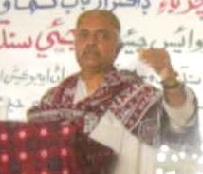
The total Population of Sindh is near about 40.5 millions from which 10 millions and 10 thousands peoples affected by flood disaster, means one fourth of Sindh population is under disaster. In Sindh, Sindhi and non-Sindhies are living; the region and areas of non-Sindhies are safe while all of the areas of Sindhies demolished and living in hell like camps. Their future is under threatening. After three months of disaster near about 5 millions peoples when returned back to their homes, there was no any sign remains of their homes, tons of river sand buried alls the towns, villages and cities which was ever full of their cultural life. Flood engulfs their hundreds of years old civilizations. Flood effecters are wondering without their future. Their health, education, means of communication every thing bulldozed and pulls down suddenly. No any governmental support and planning is seems for their better rehabilitations. What ever they are getting is from the peoples of other areas and different social organizations and NGOs.
Media was busy in celebrating the “TOPI DAY” or “Day of Solidarity”, its well to promote the culture, but for the time being media needs to extensively aware the real facts and life concerning the flood effecters and disasters to rest of the world for their future Planning and rehabilitations. I will request SINDNet also to come in the areas of disaster and look how the peoples are now having their life.

In the last Mr. Arbab Kawar sab thanked all the participants and also thanked SINDNet on arranging the tome needed lecture program.

Hi-Tea:
All the participants and guests were served by refreshment and lunch at the end of the Lecture.

_________________
(Zahoor Laghari)
Chairman,
SINDNet – Mps.

======================= (THANK YOU) =======================

Annexure – I Photographs:

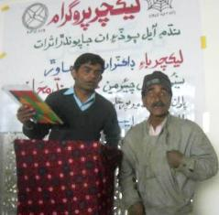
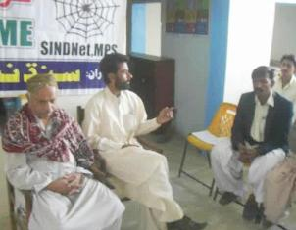

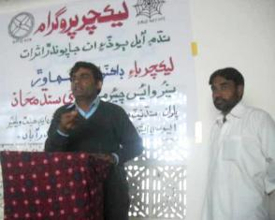

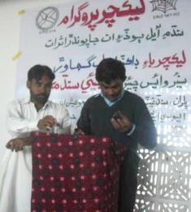

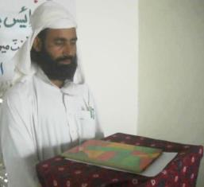
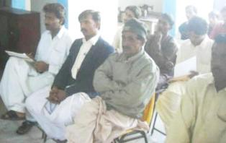

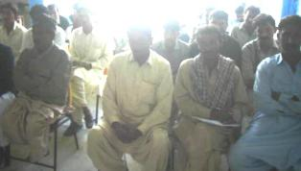
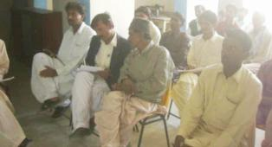
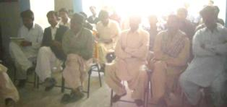

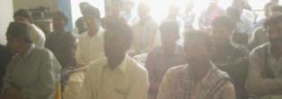
Annexure – II Participants Lists:
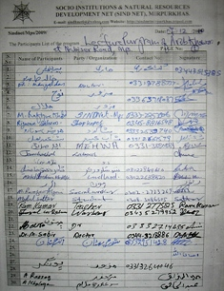
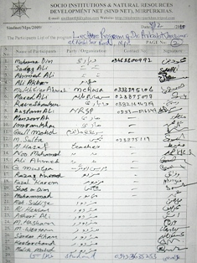
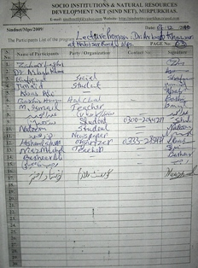

Annexure – II News Media Reports:
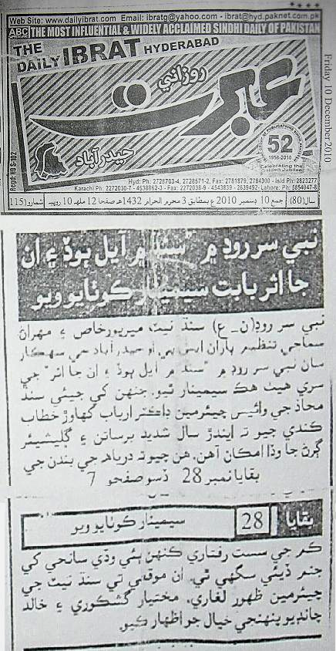

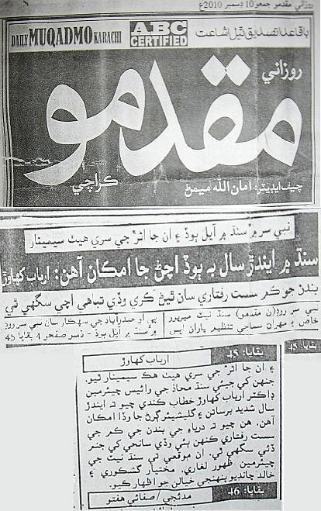
Annexure – II News Media Reports:

================= (THANKS) =================

