Cultural Event:

“KACHEHRI” FOR PEACE

Program & Reporting Team of SINDNet:
- Program Lead by:
  - Zahoor Laghari.
- Program supervisor:
  - Zeeshan Laghari.
- Supporters:
  - SPO-Hyd.
  - Members SINDNet
  - Area Contributors.
- Recording & Photography by:
  - M. Rafique Khatri.
- Report by:
  - M. Rafique Khatri.

……………………..

Program was organized by:
Socio-Institutions & Natural Resources Development Net (SINDNet), Mirpurkhas
Email: sindhnet04@yahoo.com
Website: http://sindnetmirpurkhas.tripod.com
Ph: No. 0331-2782473, 0333-2952480 & 0333-2953506.

Organized with Coordination & Sponsored by:
Strengthening Participatory Organization (SPO) Hyderabad, Sindh, Pakistan
“KACHEHRI ” FOR PEACE, Program:

Introduction of SINDNet - Mirpurkhas:
SINDNet - Mps. is an issue Based Network of 46 allied NGOs in district Mirpurkhas, working for its development, advocacy, awareness, and for uplift the average life here. It established in 2000 after successfully completion of DPM Graduate Training from SPO, Hyderabad. Due to the allied of registered NGOs, SINDNet, Mps. is an unregistered Issue Based Network of NGOs.

Coherent for the Report:
SINDNet, Mirpurkhas is trying to retain peace and peace of mind for the peoples living in the district Mirpurkhas. Such as, the efforts for development and its measures can be taken safe and sound. As in district Mirpurkhas there are very few amusements and entertain able places and also there is shortage in providing these kinds of moments for the peoples, SINDNet tried to provide some cheerful moments for the peoples of Mirpurkhas.

The main focused aim and objective is to inter-mingling the society of different age groups, race, religion and cast to create a peaceful harmony and brotherhood. Cultural Shows are the sign of cheerfully living community with communities. For restoration of peace and peace of mind, it is deem to spend some joyful moments with cheerful frame of mind in community. Cultural Shows are also standstill point of uncertain situations in society, because it engaged younger in activities. Different nations have different cultures; promotion of their culture supports the nation to enhance their values wide spread. Sindh is the area where Sindhi Nation having rich culture.

Sindhi is one of the most ancient languages among the regional languages of Pakistan and Sub-continent. The first translation of the Quran was into Sindhi. It has a rich literature ranging from religion, philosophy, medicine, Sociology, Logic, literature, history, politics and culture.
Shah Abdul Latif Bhittai, a writer of Sindhi poetry, is widely read and understood by people all over the world. He wrote Shah jo Risalo. Another popular poet is Sachal Sarmast. Shaikh Ayaz, Tanweer Abbasi, Ustad Bukhari, Fatah Malik, Ibrahim Munshi, Niaz Hamayooni, Sarwaich Sujawali, Juman Darbadar, Haleem Baghi are the major poets of new era.

“KACHEHRI ” FOR PEACE: Reflection;

Recital of the Program:
Regarding peace & sense of entertainment, SINDNet arranged a “KACHEHRI” Program for peace with Community on Wednesday dated 06th Nov: 2010 at the Ground of Govt. Primary School Mir Colony, Mirpurkhas with coordination and sponsoring from SPO Hyderabad. Program invitation was guest selected but overall it was public invitation. The classic music lover, higher officials, social & political personalities has attended the program with several younger and common peoples.

Program Presentation:
For the overall talks “KACHEHRI”, Mr. Zeeshan Laghari announced the program with a short interpreter regarding SINDNet and SPO.

- Compeering:
Zeeshan Laghari, Finance Secretary of SINDNet paid radiant and gleaming compeering with stage invitation of singers, their companions, guests and speakers.

- Introducers:
  - Zahoor Laghari: Chairman SINDNet has given a brief introduction of SINDNet to audience. He told working mood of SINDNet and told aims and objectives of the program. Also somehow he explained progress and work done by SINDNet, Mirpurkhas.

- Speakers & Presenters:
- Zahoor Laghari, Chairman SINDNet.
- Zeeshan Laghari, Sec: Information, SINDNet.
- Dr. Hussain Marri, Political Personality from “Jeay Sindh Qomi Mahaz”.
- Dr. Anand Bheel, Political Personality from “Jeay Sindh Qomi Mahaz”.
- Qadeer Hussain, Political Personality from “Jeay Sindh Mahaz”.

- Performer Musicians and Musical Groups :
    - Mr. Haleem Baghi: Poet and Classical Musician.
    - Mr. Jumman Darbader: Poet.
    - Haji Sand: Poet.
    - Hassan Junejo: Tableau Performer.
    - Baby Sunder: Student.
    - And others Audiences.

- Speakers:
- Zahoor Laghari:
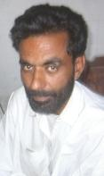
Chairman SINDNet-Mps & Leader of “Jeay Sindh Mahaz” said that Present time is the time of struggle for an independent and secular Sindh. Its can not be achieve without interrelation with all the community members living in Sindh. We must have to retain the peace among us.

- Zeeshan Laghari:
Zeeshan Laghari, Finance Secretary of SINDNet Presented the message of SUFIES and saints; of humankind and civilization. Sindh is the land of Love and sympathy. Here we can not allow any kind of terrarium or religious fundamentalism.
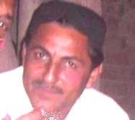
- Political Leader Dr. Hussain Marri:
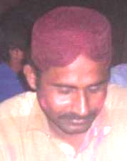
Ex. Chairman of SINDNet and Leader of “Jeay Sindh Qomi Mahaz” said that SINDNet always tried to maintain the peace in the district Mirpurkhas in favor of all the habitants, because the Peace is necessary for making the development. More he said, we will not allow any body to disturbed the any of religions context and concepts.

- Political Leader Dr. Aanand:
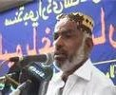
Leader of “Jeay Sindh Qomi Mahaz” said that Present time is the time of struggle for an independent and secular Sindh. Its can not be achieve without a big community of Hindu Kolhi and Bheel community living in Sindh. We must have to retain the peace among us.

- Singers and Tribute Payers:

- Mr. Haleem Baghi:
Our Famous Sindhi Poet paid Qumi Poetry and his several other independent stanzas in the prospect of harmony and humanity. He sung his poetry very well besides with and others poets of Sindh.
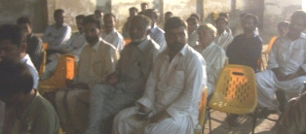

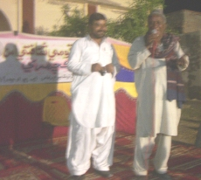
- Mr. Jumman Darbader:
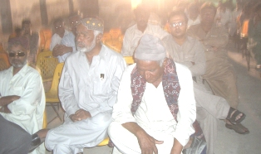
Activist and Famous Sindhi Poet paid his poetry very brilliantly and attributed to all politicians of Sindh. He made the occasion very sensitive and highly conceive event. His poetry dropped all the audience in deep thought and that what the situations of the area and live hood being thought by our politicians. The audience paid great respond on his performance and poetry by clippings’ and praises his poetry.

- Mr. Haji Sand:
Sindhi sindhi Poet presented several stanzas from sindhi poetry and amused all the audience.

- Baby Sunder:
A little Baby was also showed great interest with singing and music. She paid a poem for peace that “AAMAN ZINDA ABAD”
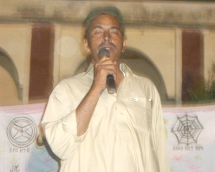
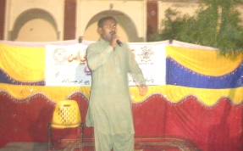

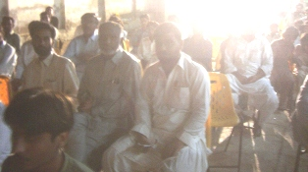
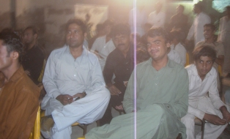

- Scenario of the program:
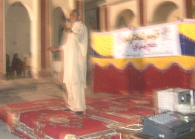
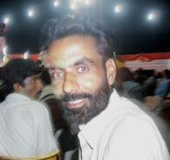
It is often said that music is the spiritual meal for human beings. In Sindh, SUFIES, saints, and many ancestors has given several human secrets of a good life through their messages in poetic way and their messages has been sung very brilliantly by several classical musicians and singers. As the Great spiritual saint and poet of Sindh “SHAH ABDUL LATEEF BHITTAI” has given us brilliant set of his messages in “SHAH-JO-RISALO” and singer “ABIDA PARVEEN” sung them very well. In her voice we can feel the reality of the words and peace of mind. Just like it, different classical musicians and singers has sung different spiritual saints and poets. In Sindh, there are many Sindhi Poets, Classical singers & musicians like, Allan Faqeer, Ustad Shafi Faqeer, Adida Parveen, Haleem Baghi, Jumman Darbader Liaquat Ali, and so on.

- Audience of the program:
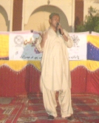
The audience of the program paid great respond to their all the favorite performing singers. During entire the program they retain the joyful situation and enjoyed much. There a number of the officials and social activists was also listening the music. Officials of Education, Agriculture, Irrigation and Revenue departments have attended the program. Social organizers related to their NGOs were also present there and enjoyed well. And a number of younger was too much there, amusing the musical program well.

- Program Recording:
An arrangement of Eco-Sound System, Audio & Video Recording and Generator for power supply has been equipped there in the Program.

- At the END of the program:
The Program was start at 7:00pm and last at 10:00pm at Night. The entire program was successfully completes its duration.

_________________
(Zahoor Laghari)
Chairman,
SINDNet – Mps.

======================= (THANK YOU) =======================

