We recognize the immense and critical contributions that women make daily to the welfare of their families, the development of their communities and societies.

Report of Women Meeting
Held on 21st June 2010, at the Venue of P.F Public School, Mirpurkhas with Collaboration of Straighten Participatory Organization (SPO) Hyderabad.

Report of Women Meeting:

Introduction of SINDNet - Mirpurkhas:
SINDNet - Mps. is an issue Based Network of 46 allied NGOs in district Mirpurkhas, working for its development, advocacy, awareness, and for uplift the average life here. It established in 2000 after successfully completion of DPM Graduate Training from SPO, Hyderabad. Due to the allied of registered NGOs, SINDNet, Mps. is an unregistered Issue Based Network of NGOs.

Coherent for the Report:
Sindhi women reflect today on the status of women all over and particularly in the developing Areas.

We recognize the immense and critical contributions that women make daily to the welfare of their families, the development of their communities and societies. Often their contributions are discounted or unappreciated. Women all over have come a long way. Despite obstacles and gender- informed barriers and limits, they have worked within and around every difficulty to keep things together for their families and communities. There’s progress and opportunities for women to become visible and vocal partners with men in developing their societies in many sectors, but there is still a lot of work to be done in order to protect the smallest rights of human beings, where women and girls are concerned in some others.
We think of women in the middle of crises, be they conflicts many natural and cultural disasters. As they struggle to keep their families together with little or no rations, always encouraging and speaking hope to quell the fear rising in the hearts of their children, they who will have no one to minister to their own rising panic will have to breath deeply in order to find the strength within their core to carry on… to just get up and keep going.

Recital of the Report:
The Women Meeting for recognizing women through formation of different activists women social groups, was held on the day of Monday, Dated 21st June – 2010 with time of 11:30am to 4:00pm at the IDARO-Office (P.F Public School), Mirpurkhas. This Women Meeting was attended by most of active and energetic young women who have will to manipulate the entire women difficulties, troubles and crises.
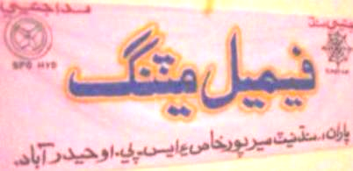

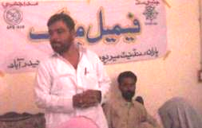
Women Meeting:

Reflection:

Compeering of the Meeting:
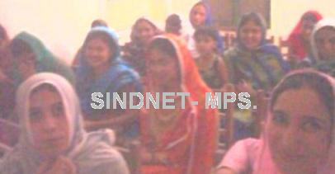
The Finance Secretary of SINDNet Mr. Zeeshan Laghari has not only played a role of compeering, but also has presented helping information and managed the meeting very well. During his compeering, he was using helping words to urge female participants to be aware well for wellbeing of their sisters with the joint shoulder of their male living in the society.

Orators of the Women Meeting:
Initially, the Women Meeting held to form the Women groups, whereas most of the female participants of current meeting were having hesitations being inactiveness, while all of them were well educated and well knowledgeable. Soon after, they realized to narrate the realities and crises of a woman.

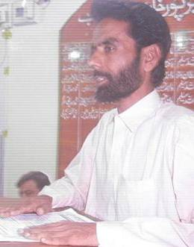
Mr. Zahoor Laghari: Chairman SINDNet Mr. Zahoor Laghari has welcomed and thanked all the guests and participants. He said that SINDNet is working on many different issues of our area. Education, Health and Agriculture are those sectors where not only man but women are also struggling more than the man struggles. But unfortunately, women and girls are concerned in some others. It is due to the inactiveness of women. Now SINDNet has aiming to activate the women which is more than 50% of male population. More he added that in our district Mirpurkhas, there is no influence able women organization or network, can be able to highlight the women real crises and problems. It is our Sindhi women, who can feel much better to share their curse with females. Such as in Medications, Education, Politics and cultural crises of women are needed to be solved by women members. SINDNet has done many women program and events. SINDNet deemed to format a women group of women activists with the help of female members of SINDNet and with coordination of SPO-Hyd. The chairman of SINDNet emphasized to give full support and coordination at any stage and at any time whenever women group needs. More over he added, SPO Hyderabad is our partner supporting organization and will assist the women in organizational trainings and structures. At the last he hoped, today we not only can form the women group of activists but also formulate the structure and mottos of the group.

Madam Zakia: Secretary Women Affair of SINDNet madam Zakia first thanked all the female attendees of the meeting and stated the importance of women in the society. She said being a woman I can feel the problems of women. In our society women are very depressed and confused due to the male attitudes with them. Apart of it, several men made religious and cultural ban retained them only in houses. We as women have to differentiate them and well attentive to know the real truth. It is only in our struggles for welfare of females. It is time to hand in hand accessible for comprehensive approaches in every field of life. I will request all of the female participants to be members of the Women Group and work for bright future of women.
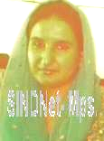

Miss Madhiha: A fresh Graduate lady of the area said there are many opportunities for women to work in social sector. In the Sindh, only few women are working for the welfare of women while the women are more than the male population. It is a good chance for us that SINDNet is providing us a platform and full support concerning the current issues of our district. I am very thankful of SINDNet and like to be member of the women group. For other women, I would like to show and say that our women are depending on the permission of dominating male home members. I will suggest, first a group of few women visit with the home members of the expected women members to convince for help of women.
Miss Zonerah: A teacher and active in social efforts for wellbeing of women, first thanked for invitation and than complained women that it’s necessary for the time being to be with hand in hand in solving our problems. But it is so sad that only few of you women attended the meeting. She suggested, for formation of an organization type group, first we have to motivate educated employed women like teachers, lady doctors and students.
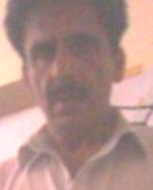
Mr. Aziz Laghari: Social Activists and administrator of PF School said, this better occasion for women which SINDNet and SPO – Hyderabad is providing for welfare of women. It is the best way to solve women crises by women. In Mirpurkhas district, there is no any strong and active team or women organization if you succeed in formation of women group, it will be fist page tire of women organization. It is my pray for successions of women group.

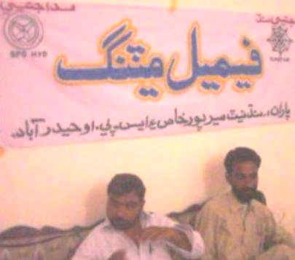

Suggestions:
Most of the following common suggestions made during the Women Meeting;
- First a group of few women visit with the home members of the expected women members to convince for working in help of women.
- For formation of an organization type group, first we have to motivate educated employed women like teachers, lady doctors and students.

Formation of a Committee:
In the light of suggestions made by participated women, before shaped a structure of the Women Organization or Group, it was deemed to form a committee working for motivation.
Following women members selected for the committee;
- Madam Zakia.
- Miss Madhiha.
- Miss Zonerah.
At the end of Women Meeting, the Lunch with cold drink was served to all the attendees of the meeting. Overall, The Women Meeting was successive increasing the will of social activity and motivation.
-------------------------------------- (THANKS) --------------------------------------

