
“Mango is our Ambassador”

Report of “SINDNet Cultural Stall”, Held in Mango Festival, Mirpurkhas.
Held on 4th, 5th and 6th June 2010, at the Venue of “SHAHEED BENAZEER BHUTTO MANGO FESTIVAL HALL” Fruit Form, Mirpurkhas with Collaboration of Straighten Participatory Organization (SPO) Hyderabad.
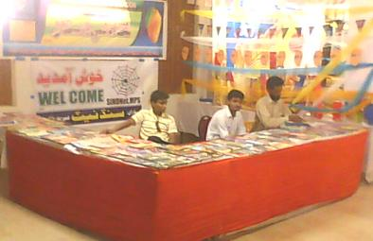
Report of “SINDNet Cultural Stall”, Held in Mango Festival, Mirpurkhas:

Introduction of SINDNet - Mirpurkhas:
SINDNet - Mps. is an issue Based Network of 46 allied NGOs in district Mirpurkhas, working for its development, advocacy, awareness, and for uplift the average life here. It established in 2000 after successfully completion of DPM Graduate Training from SPO, Hyderabad. Due to the allied of registered NGOs, SINDNet, Mps. is an unregistered Issue Based Network of NGOs.

Basic Rational with history:
Sindh is the second largest province of Pakistan; it has very rich and strong cultural traditions and costumes. It is also proudly said that Sindh having very old civilization of “Moen-jo-Daro”. Also the climate of Sindh is very favorable for agricultural point of view. For the time being; the shortage of water is effecting in agric productions very much. The most common croups of Sindh are Cotton, Wheat and Sugarcane. But in fruit; Sindh has a very dominating district in production of Mangoes.

The Mirpurkhas district is known as the “City of Mangoes and NGOs”. The Mango of district Mirpurkhas is now acting a role like an ambassador of district Mirpurkhas. Here it is often said that “MANGO IS OUR AMBASSADOR”. The mangoes of Mirpurkhas are not only nationally but also internationally likes very much. Here, agric researchers invented hundreds of different varieties of mangoes. The “SINDHRI MANGO” is the king variety in mangoes.
For the well admiration of mangoes, The Sindh Horticultural department of Mirpurkhas and activists of NGOs made display like arrangement as “Mango Festival” to honor the mangoes with the growers of mangoes. The first Mango Festival was arranged on 27th June 1965. After this, it is near about consecutively holding-up every year. Now a day, it has the shape of district’s most cultural event. Also the competition among the best mango growers is holding up. Now the Mango Festival has three major categories, first Mango displayers, second cultural displayers and third “MEENA BAZAR” for ladies and kids. Fire works and musical shows are extra interesting and attractive activities.

Recital of the Report:
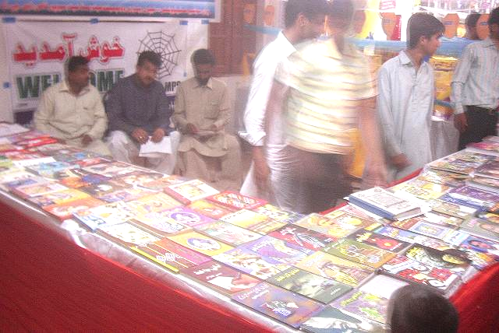
In aspect of the district’s most cultural event of “Mango Festival”; SINDNet, deemed to participate the festival under the Cultural Displayer’s Category for promotion and to highlights the SINDNet among the national and international participants and media. It is best forum to display the aims, achievements, visions and issues of SINDNet Mirpurkhas. For the last three years, SINDNet is consecutively displaying stall in the Festival.
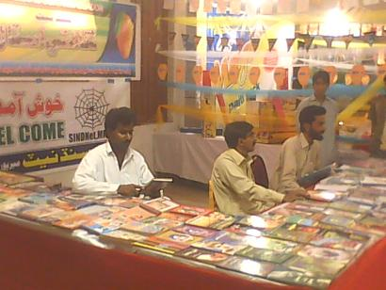
This year the Mango Festival was arranged on 4th, 5th, and 6th June 2010 at newly constructed, well equipped and centrally air-conditioned hall named “SHAHEED BENAZEER BHUTTO MANGO FESTIVAL HALL” Fruit Form, Mirpurkhas. For participation to display a stall SINDNet arranged a stall in it and SINDNet displayed books and literatures of Sindh with the entire well bannered, attractive and prominent manner.

Coordination in arranging the “SINDNet Cultural Stall”:

SPO Visited the Stall:
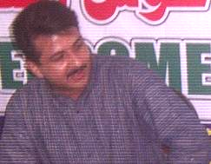
The SINDNet Cultural Stall was arranged with collaboration and financial support of SPO Hyderabad. SINDNet is very thankful for their facilitations. The Program Officer Mr. M. Jameel Munawer Abro has attended the Stall and visited the entire Mango Festival.

Inauguration of Mango Festival:
Basically, the Dialogue Program is to collect the suggestions from civil society and inform the higher authority for better legislations. Due to the unavailability of current published information and knowledge about 18th amendment, for speakers it was seemed hard to fluently speak.
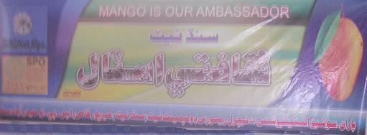

The SINDNet Cultural Stall:

People’s Interest at SINDNet Cultural Stall:
At the Cultural Stall of SINDNet, several participants from all over the country and outside country visited the Cultural Stall and got aware about the SINDNet, Mirpurkhas. The Cultural Stall was arranged with the entire allied member NGOs/Parties of SINDNet. The member NGO, named Indus Development Action Research Organization (IDARO), Mirpurkhas helped very much in arranging this Cultural Stall. There also SINDNet and IDARO distributed their broachers and pamphlets among the participants.
Peoples paid great attention and taken keen interest at SINDNet Cultural Stall. They not only bought books but also were anxious in knowing about SINDNet and SPO.

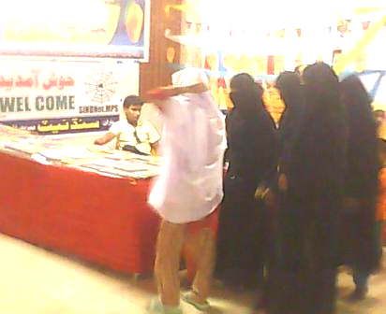
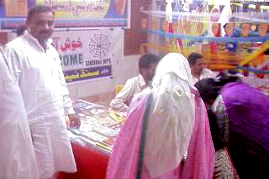
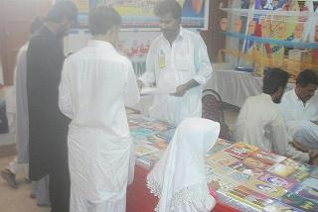
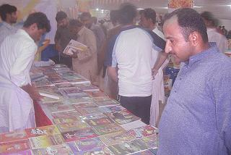
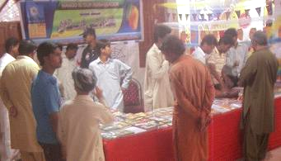


People’s Comments with attendance at SINDNet Cultural Stall:
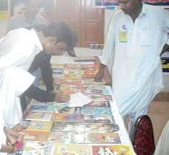
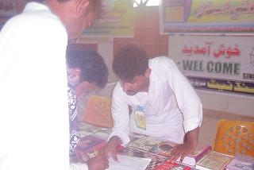
At the Cultural Stall of SINDNet, a number of Participants of the Mango Festival felt great pleasure in writing their comments in the Visitors Book with signing in the attendance sheets. Most of the Participants of the Mango Festival were Govt. Officials, intellectuals, activists and Journalists.
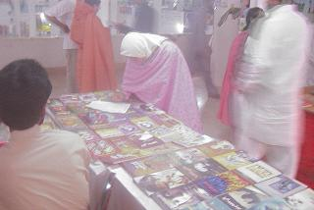
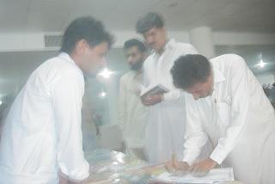


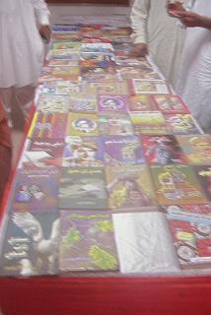
Books Placed at the SINDNet Cultural Stall:
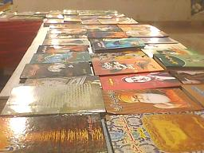
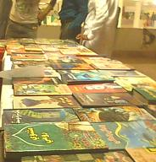

Mango Festival Hall:
The newly constructed, well equipped and centrally air-conditioned Mango Festival Hall named “SHAHEED BENAZEER BHUTTO MANGO FESTIVAL HALL” at Fruit Form, Mirpurkhas, was beautifully decorated by every stall owner and rich culture of Sindh was given the impression of being a Festival.
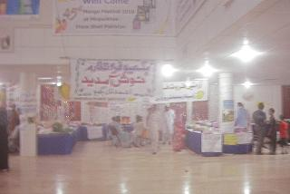
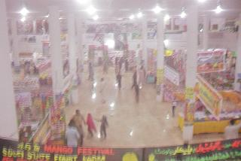
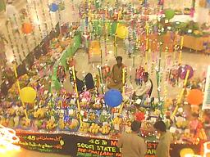
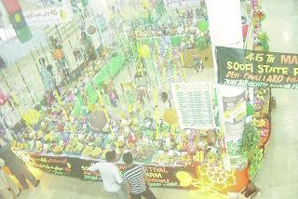
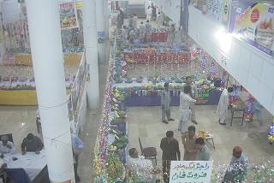
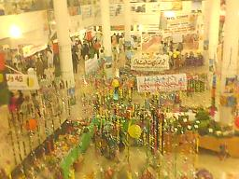
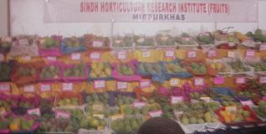


Different Kinds of Mangoes Placed at Mango Festival Hall:
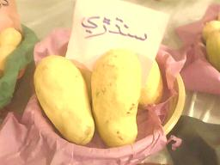
All the kinds of Mangoes from all over the Sindh fetched in the Festival. A Mango was so special due to the name of Messenger “MUHAMMAD” written on it naturally.
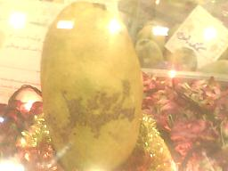
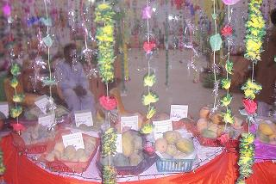
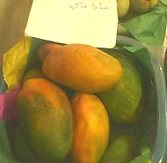
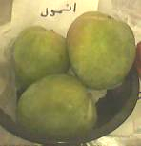

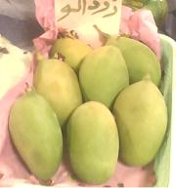
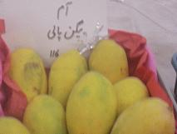
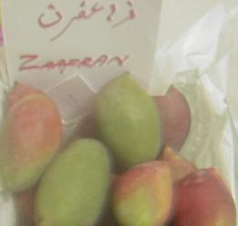
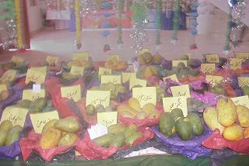
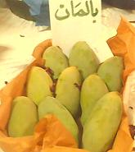
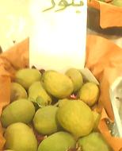


SPO’s Program Officer Visited the SINDNet Cultural Stall at Mango Festival Hall:
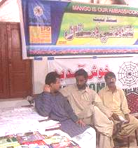
The Program Officer Mr. M. Jameel Munawer Abro has attended the Stall and visited the entire Mango Festival.
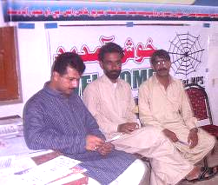
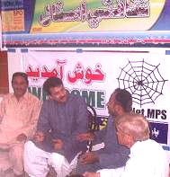
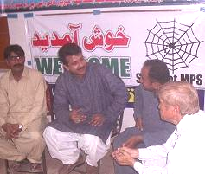
The electronic media and Newspapers have given main page coverage of entire program, where we also have interviewed by several media journalists. The highly officials and intellectuals visited our stall and paid courage. During all the three days of Mango Festival, peoples showed their keen interest in our stall being informative books and literatures of Sindh.

Internet coverage of “SINDNet Cultural Stall” (Mango Festival) at:
(If online: CTRL + Click to view recorded movie)
- http://www.youtube.com/watch?v=td62N5ttyZI
- http://www.youtube.com/watch?v=XlOjQachfNk

Overall, the holding a Cultural Stall in the Mango Festival was a great enhanced to promote the SINDNet, Mirpurkhas.

_____________________ (THANKS) _____________________

